**QSMART – CG KITS REPLACEMENT**

**PROCEDURE**

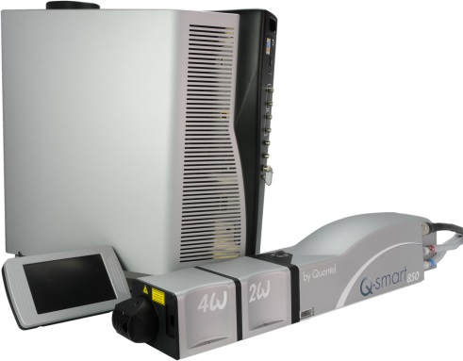

**Toolkit:**

Allen keys

**System**: QSMART

|  |  |  |  |  |
| --- | --- | --- | --- | --- |
| RE030005A | **Q-SMART CG LEVEL SENSOR** | | | |
|  |  |  |  |  |
| **RE030006A** | **Q-SMART CG FLOW SENSOR** | | | |
|  |  |  |  |  |
| **RE030007A** | **Q-SMART CG TEMP ENSOR** | | | |
|  |  |  |  |  |
| **SM010375** | **Q-SMART CG PUMP ASSEMBLY** | | | |

**Purpose**: This document details how to change the sensors kit

|  |  |  |
| --- | --- | --- |
| Revision | date | modification |
| Initial issue | July 4, 2014 |  |
|  |  |  |
|  |  |  |
|  |  |  |

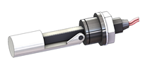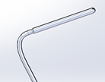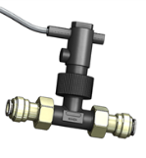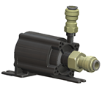

# DISASSEMBLY

* Open the ICE and the cooling group

*See procedure " CG - SM010355-COOLING GROUP ASSEMBLY "*

# Implementation of the CG level sensor

Inserted the level sensor (4/CAP/0056) into the side hole of the tank like shown (with the float down).

Tighten the nut when the seal is in contact with the tank.

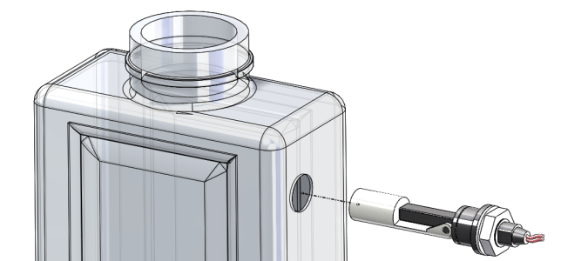

# Implementation of the CG debit kit

|  |  |  |
| --- | --- | --- |
| 2.00 | 3/E10/0491 | UNION SOCKET PI451214FS JOHN GUEST |
| 0.22 | 3/E10/0440 | POLYETHYLENE TUBE 3/8 |
| 1.00 | 3/E10/0400 | RETAINING BRACKET JOHN GUEST PM2610S |
| 2.00 | 4/CON/1029 | CONTACT (M) FOR MPC4 18-24AWG |

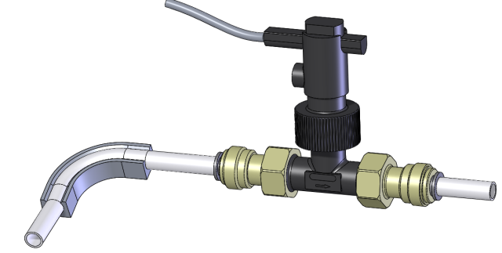

4/CAP/0057

3/E10/0491

3/E10/440 : 45mm

3/E10/440 : 170mm

55mm

3/E10/400

Direction

* Cut the debit sensor wire at 340mm.
* Remove 8cm of the double jacket and put a heat shrink over the splice. Remove insulation over 3mm
* Insert on each end a 4/CON/1029

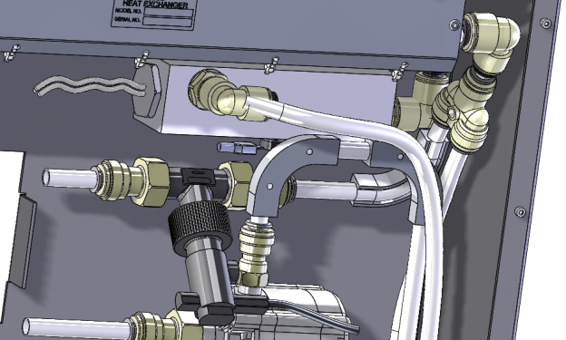

Fit the tube of the flow rate detection in the Y

# Implementation of the CG pump kit

|  |  |  |
| --- | --- | --- |
| 1.00 | 3/E10/0491 | UNION SOCKET PI451214FS JOHN GUEST |
| 1.00 | 3/E10/0596 | UNION SOCKET PI451222S JOHN GUEST |
| 0.07 | 3/E10/0440 | POLYETHYLENE TUBE 3/8 |
| 2.00 | 4/CON/1029 | CONTACT (M) FOR MPC4 18-24AWG |

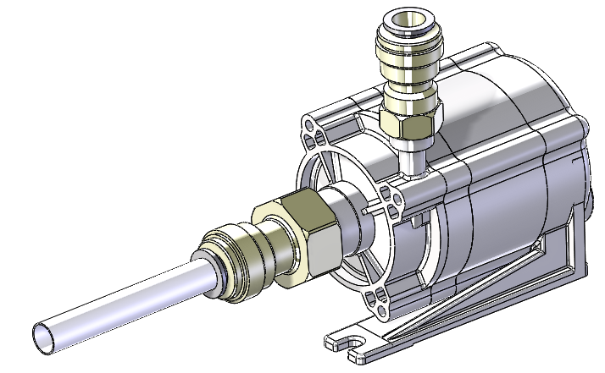

Put Fileplast dough on the threads of the pump before screwing fittings

3/E10/0491

3/E10/0596

3/E10/440 : 80mm

* Cut the pump wire at 330mm
* Remove 8cm of the double jacket and put a heat shrink over the splice. Remove insulation over 3mm
* Insert on each end a 4/CON/1029

|  |  |  |
| --- | --- | --- |
| * 2.00 | 3/E13/0600 | BLACK BHC COLLERETTE M4 SCREW |
| 2.00 | R/MU--D04--A2 | MU4 WASHER |
| 2.00 | E/NYLSM04--A2 | NYLSTOP M4 INOX A2 NUT |

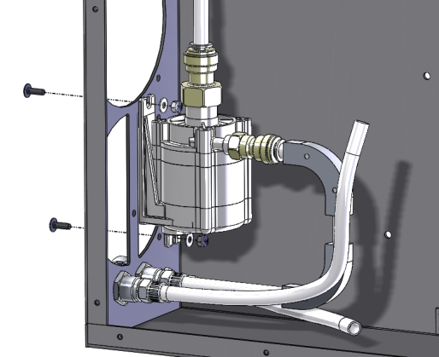

Fix the pump with 2 black screws BHC + MU4+ nut Nylstop M4.

Insert the outlet pipe of the pump into the fitting

# Implementation of the CG temperature sensor kit

# 

1- Screw the sensor into the tank

# WIRING

* Connect the cables that have been disconnected

*Refer to "CG-Wiring"*

# TEST AND CLOSING

* Perform the test of CG and close.
* Close the ICE

*Refer to "CG-Test & closing" and "CG - SM010355-COOLING GROUP ASSEMBLY"*